Computer Graphics
as Allegorical Knowledge:
Electronic Imagery in the Sciences
Richard Wright

Richard Wright (artist, educator). Computer Graphics Department. City of London Polytechnic, Tower Hill, 100 Minories. London EC1N IJY, United Kingdom. Email: uk.ac.clp.tvax.rq_wright
©1990 ISAST
Pergamon Press plc. Printed in Japan. 0024-094X/90 $3.00+0.00
LEONARDO Digital Image—Digital Cinema Supplemental Issue, pp. 65-73, 1990

Abstract - This informal paper studies the effects of the recent introduction of computer-generated imagery on the practice of science and its function in understanding the world. It intends to introduce the subject of computerised visualisation for scientific purposes into a wider debate, to show the diversity of issues involved—scientific, cultural and philosophical—and to build a context in which they can be critiqued. The author seeks to show the variety of scientific imaging and its influences on scientific knowledge; as both experiments and results are increasingly expressed in terms of imagery, the image assumes an integrity of its own and the object to which it refers becomes obscured. This leads to a shift of focus away from abstract theory as the embodiment of knowledge to the ascension of an allegorical image-based science with computer graphics as its natural language.

In 1987 the Panel on Graphics, Image Processing and Workstations of the U.S. National Science Foundation published its report on Visualisation in Scientific Computing (ViSC), which recommended that all scientists and engineers should be provided with their own computer-graphics workstations as well as access to advanced computer visualisation facilities [1]. Thus has the agenda now been set for the majority of scientific work to be conducted through the medium of computing in general and computer graphics in particular. Although the impact of such technology on the practice of science is not in question, its implications for the nature of scientific knowledge itself have received little attention.
The orthodox position on scientific use of computer graphics views it as an almost pre-scientific tool for the analysis of empirical or other data—a preliminary and informal stage at which the scientist can gain signposts for further promising investigation by more traditional and rigorous means. But in fact the whole context of scientific work is changing. Scientists now place more emphasis on being able to ‘see’ what they are doing. They desire to change the level of abstraction at which they are working from one of purely conceptual and ideal objects to their realisation in dynamic simulations and visual feedback [2]. And this in turn shifts their commitment away from abstract theory and numbers in scientific investigation to a concentration on its visual forms, using intuitive perceptual qualities as a basis for evaluation, verification and understanding. The ViSC panellists refer to this process as merely “putting the neurological machinery of the visual cortex to work”, but the mechanical and utilitarian terms in which this view is expressed should not hide the fact that the cognitive role of imagery in the minds of scientists goes much deeper. Scientists have always mentally ‘visualised’ problems, but now the imagery is externalised, objectified, and constitutes understanding itself rather than making theory more accessible.

Many characteristics of computer graphics conspire to make scientific imagery in itself a constituent of knowledge apart from its value in crystallising concepts. These characteristics include the continuous surface of many computer images that lack discrete pictorial elements with fixed diagrammatic references, the inscrutable algorithmic processes by which formulae and data are transformed into visible output, and the multitudinous array of visualisation techniques and parameters possible, often of equal intrinsic validity.

In the study of complex phenomena many problems can be answered only by direct simulation or collections of data far beyond the scale of human assimilation. These activities can often be expressed only in terms of imagery. Furthermore, in the inexact sciences that attempt to model highly contingent events, a form of ‘pure’ simulation is emerging that seeks only to reproduce the behaviour of phenomena without any pretence to a theoretical understanding. In these cases the generation of visualisation imagery could assume the status of a common epistemological currency—the creation of a visual knowledge.

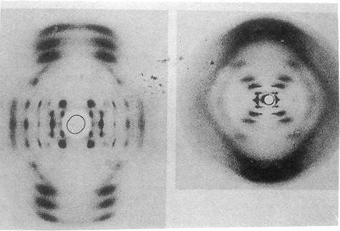
Fig. 1. DNA X-ray diffraction photograph. from J. Darius, "A Concise History of Scientific Photography", in Beyond Vision (Oxford University Press, 1984). Reprinted by permission. R. G. Gosling and M. H. F. Wilkins, 1950 (left), R. E. Franklin, 1952 (right).
The picture on the right was finally decoded after careful measurement by Crick and Watson as indicating an intertwined double helix structure, after Franklin herself had apparently lost interest in the helix hypothesis.

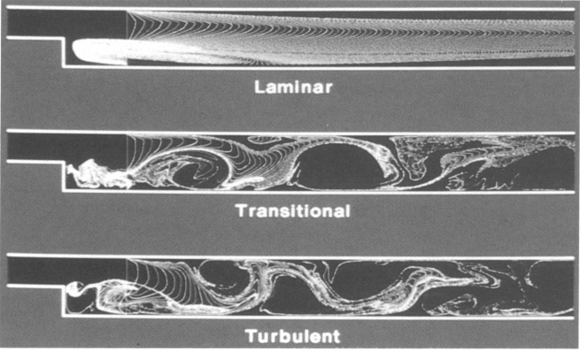
Fig. 2. Real-Time Bubble Injection. J. B. Salem (Thinking Machines Corp.), J. A. Sethian (Univ. of California, Berkeley) and A. F. Ghoneim (MIT), digital image, 1988. (Photo: J. Salem) Copyright 1988 Thinking Machines Corp. Reprinted by permission.

VISUALISATION IN SCIENTIFIC METHOD

The drive towards a totality of understanding or ‘finality’ in scientific research has resulted in the desire to acquire immense amounts of information about a phenomenon to ensure certitude and has led to what has become known as the ‘firehose of data’ effect. For years satellites and radio telescopes have continuously transmitted to laboratories on earth signals that scientists simply do not have the facilities to examine efficiently and must 'ware-house' until techniques become avail-able. Added to this data are new channels of information provided by geophysical instrumentation, medical scanners and the results of supercomputer simulations, the resolutions of which also constantly increase. The sensitivity of events in complex natural systems to nebulous external influences, as well as the possibility that the most innocuous observation might make some essential contribution, has brought scientists to the classical dilemma of empirical research.

Mechanical instruments were first used at the stage of experimental testing, to allow empirical data to be unambiguously apprehended and measured. Controlled laboratory conditions were required to purge perception of human error and allow factual observation to flow into the scientific consciousness unimpeded. But in order to compare experimental results with statements of theory it was still necessary to express them in similar terms. Much effort was made in the first decades of the century by the logical positivists to develop a `language of observation', a language of neutral terms into which both theory and fact could be translated in order to evaluate their `correspondence'. It was this final project that proved vulnerable to the criticisms of conventionalist epistemologists like Thomas Kuhn [3]. There is no way to decide on a completely objective standard of reference; the terms in which experience is ordered and recorded cannot be theory-neutral. Although logical positivism as a philosophy has passed into history, its ghost lingers on in the form of a dogged adherence to the notion of scientific activity as a formal matter of deducing mathematically defined relationships from the observable quantities that present themselves, while paying lip service to something vaguely called `scientific creativity' to account for the innovations and deviances that do not fit this pattern.

Scientific insight does not flow uninhibitedly merely from the diligent recording of observations. Furthermore, the assimilation of these facts for the deduction of hypotheses is practical only on a small scale, for reducible, mechanical or localised phenomena. Outside these narrow boundaries scientists have the choice either to find methods to automate the analytical process or to supplement the limitations of empirical research with more efficient theory generation. The possibilities offered by computers and graphics make both these approaches feasible.

Contemporary research into the psychology of perception strongly suggests that the ability to see forms is the result of a learning process, based on the exposure of the developing infant to the visual characteristics of its surroundings [4]. This means that the power of perception, though repeatedly tested against everyday situations for accuracy, is dependent on the contingency of the experiences of each individual subject. The existence of simple optical illusions indicates that these learnt responses to stimuli are vulnerable to errors in unfamiliar circumstances. It has also come to light that even the low-level orientation-detecting cells of the visual cortex are not entirely innate but need to be fully exercised if they are to develop correctly; otherwise basic perceptual abilities will be impaired [5]. In principle, therefore, we cannot with any certainty trace the results of the process of visual perception to the object that caused them: we cannot be sure of what we see. Although this fact seems to militate against the use of visualisation techniques as an analytical aid, it is also the main reason that visual perception is so powerful as a tool. The extreme situations that produce optical illusions do not occur in most applications of computer graphics. The study of graphical depictions usually involves a simple visual monitoring or feedback of computational processing. But the ability to perceive tenuous relationships between subtle fluctuations in data derives from the flexibility and sensitivity of vision that is the flip side of its ambiguity. This unpredictability permits `creativity' in knowledge generation and allows alternative and potentially more valuable hypotheses to come to the surface for consideration [6].

If empirical research is to remain practical in an age of increasing data bandwidths, more powerful methods of analysis must be developed, particularly visualisation techniques. But these retinal methods of intuitive research harbour no pretensions to the aloof objectivity of an observation language. Computer graphics, with its variety of technical contingencies and perceptual subjectivity, is anything but a neutral analytical tool, but this is precisely its strength—and the weakness of traditional analysis, now reduced to post-rationalising the visualisation process. Mathematical rigorists can remain sceptical of the value of this retinal dissection and maintain that ‘pictures don’t prove anything’, for what reason could there be to investigate one feature of our data over any other just because it looks more interesting? But this is the situation that we must now recognise: to trust our eyes and accept that we can no longer thoroughly analyse empirical data down to the last mote, if we wish to extract useful information.

Nor can we investigate complex systems by drastically simplifying them into manageable sets of equations. Phenomena do not have to be reduced to fundamental laws in order to be under-stood, but need to be shown as they work themselves out in practice [7]. When these patterns of behaviour are expressed visually they can be comprehended by intuition in their full complexity.

Computer imaging strategies have now become not only the means by which knowledge is derived, but also the way it is presented and communicated—in effect, the way knowledge is constituted in the mind of the scientist. The goal of much current research in computer graphics is to increase the efficiency of disseminating research results in forms of imagery. In electronic scientific journals, papers are published as electronic mail accompanied by digital graphics and animated sequences as well as interactive graphics [8]. This enables readers and reviewers to study experimental evidence in much the same form that the author experienced it. Once again the abstract theoretical substrata of natural laws are displaced from the focus of attention and we become more aware of science as a consensual process, accepting the experimental techniques that best satisfy the pragmatic results we desire. Mathematical algorithms can generate effects that agree with observations, but an abstract unifying concept to explain why they work is slipping ever further over the epistemological horizon, leaving us gazing wistfully at its afterimage on our VDU (visual display unit) screens.

The visual properties of numerical imagery have to be accepted as sufficient to demonstrate an 'unseen' natural force at work, or at least as a preliminary indicator of such. This view implies that the visualisation of phenomena can be identified with the phenomena themselves. Such is the case where computer models have been used as substitutes for experimental testing, especially in areas that touch political and ethical problems such as building atomic weapons or testing medicines and cosmetics on live animal subjects. In instances where graphics are used to visualise something without direct reference to the eternal world—such as an abstract system of pure mathematics (which formally any algorithm could be) - imagery may assume the status of a 'real' object. Without anything to compare it against, it seems that this must be what a particular mathematical object actually `looks like'.

Now that mathematical as well as other scientific objects can exist on the retinal as well as theoretical level, we might enquire what effect computer graphics has in realising scientific research as imagery—in the form of electronic visualisations rather than the ruler and compass of yesterday—how computer graphics affects our perception of these objects and our reaction to them.
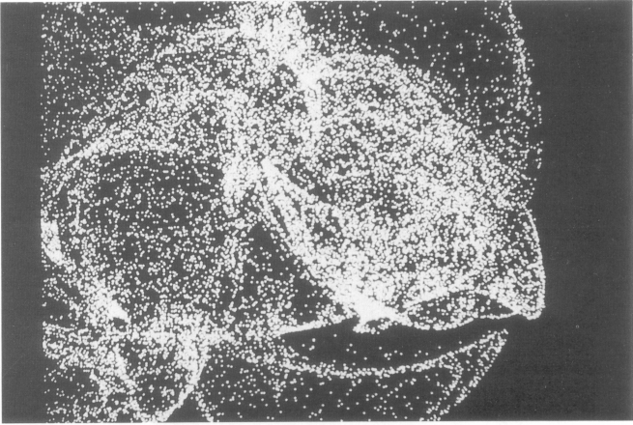
Fig. 3. Malcolm Kesson, strange attractor, digital image, 1989. Reproduced by kind permission of the artist. All rights reserved.

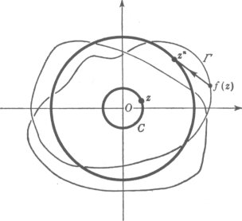
Fig. 4. Fundamental Theorem of Algebra. Topological proof that "in the field of complex numbers every polynomial equation has a root". The complex numbers here are `visualised' as points in a plane to aid conceptualisation. Source: R. Courant and H. Robbins, What Is Mathematics? (Oxford Univ. Press, 1941) p. 270. Reprinted by permission.

THE IMAGE AS OBJECT

The Phenomenology of the Electronic Image

Much scientific visualisation does not involve computer graphics [9]. In fundamental physics the bubble chamber is used to record the paths of subatomic particles resulting from particle accelerator experiments. X-ray diffraction patterns are widely used in the fields of atomic radii, crystallography and molecular biology. But if we compare examples of these with recent electronic visualisations of the dynamics of turbulence or archaeological reconstructions we see clear differences in the quality, the phenomenology, of the two types of imagery (Figs 1 and 2).

The surface of an electronic image is `photographic' in quality. It is composed of smooth tones and graduations rather than keenly delineated shapes and edges; it is unstable and fluid rather than linear and graphic. The pictorial elements that make up these images are not sharply differentiated. They are often difficult to measure and resist strict zones of demarcation [10]. As a result, each element of the image may not correspond straightforwardly to some property of the phenomenon it is supposed to visualise. Such images are not diagrammatic in function; since they generally lack lines and shapes that might represent forces or components, their shifting and floating surfaces cannot easily be split up and labeled. Many pictures are 'holistic' in character: the points that make up a Heron map depend on the mapping function as a whole and not on any particular coefficient or term (Fig. 3). We cannot isolate a group of pixels and analyse what they represent in any useful way. Such an image is to be perceived for subtle visual relationships between areas, qualitative properties for which the human eye has retained its superiority over measuring devices [11]. This is of course why visualisation has become so important, because scientists need to be able to detect very subtle relationships in phenomena that are not reducible in any obvious way to simpler formats.

The information in a computer image is much richer than that in a diagram, because the form of the information is different. It has latent content, several alternative interpretations being possible [12]. A lexicon for reading synthetic imagery is not always conveniently available, because the properties of the function the image represents are not always known beforehand. New scientific imagery needs to be analysed like artistic imagery, semantically rather than lexicologically. Its surface is composed of continuous signifiers as in a conventional photograph or film, not a series of discrete signs and symbols each with their associated meaning as in a graph or plan (Fig. 4). Computer-generated graphics are not expressions of abstract theoretical explanations but rather visual analogues of events. In them, we have an effect of the 'video culture' in its most potent form: scientific knowledge shifting from a linguistic base to an image base, replacing the positivism of the sign with the semantics of the object.

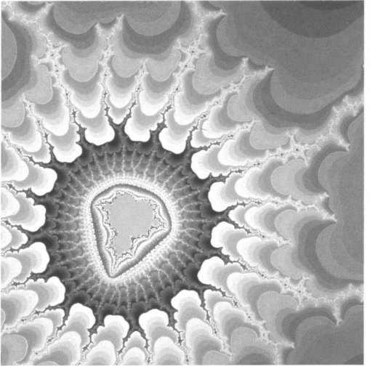
Fig. 5. Richard Wright, Mandelbrot set, digital image, 1987.

Electronic imagery is by definition created by no manual or tangible process. On examining a synthetic image we sec that it is too delicate, too precise to have been executed by the human hand (Fig. 5). It does not look 'mechanistic' either, and lacks the regularity or symmetry that we associate with graphs and chart plotting. In fact the image shows no evidence of craftsmanship, no brush marks, perhaps no straight lines. This leads to an associated phenomenological effect of synthetic imagery—that it has not been made, that somehow it has occurred naturally, like the swirling patterns of oil in a puddle. It is as if it has been invoked by human agency but not created by it. And this effect need not be entirely a perceptual effect, for such is the sophistication of modern digital processing and image generation that it is most unlikely that viewers can grasp the method whereby numerical data and formal relationships have been transformed into the tableau that confronts them. And even if they did have greater knowledge of the process, or only a general one, the gap between conceptual understanding of the means of production and the perception or visual understanding of the picture on the VDU is so great as to render the one seemingly irrelevant to the other. Some graphics generated by functions with chaotic dynamics are mathematically as well as phenomenologically indeterminable, constantly changing and resisting any attempt to resolve their pattern of growth.

Graphics users find themselves increasingly distanced from the products of their labours. Even for computer programmers there quickly comes a moment when they no longer retain precise understanding of their own algorithm, and indeed this is where part of the excitement of programming conies from—the feeling that the algorithm has taken on a 'life of its own'. Usually this perception does not impair an individual's effectiveness: programmers do not need to get to the bottom of every function they use, nor do users need to be able to fathom the deepest complexities of the packages they work with. But the level of comprehension of the process of image generation always affects its perception. The result is a dislocation from the final output. When staring at the visual subtleties of a numerical image, its creators simply do not know how it got there. This deterministic alienation reinforces the visual autonomy of computer imagery. Our inability to empathise with the logical complexities of the machine encourages the emergence of a digital mythology to compensate and account for the more dimly apprehended events seen on the screen. It most often manifests itself as a tendency to anthropomorphise, historicise and romanticise every aspect of the machine (as in anecdotal accounts of programs that work only for their creators and no one else).

The authority associated with antique geometric diagrams was based on the fact that they were built up line by line from relationships between the simplest conceivable pictorial elements. Visualisation graphics are derived from mathematical relationships implicit in procedures rather than from explicit geometrical ones. Rather than directly corresponding with the workings of natural forces and of dynamical mathematical functions, intuitive pictorial relationships only allude to or imply them. The resulting absence of the purely referential function in the image distinguishes it from the function of the diagram or graph (Figs 6 and7). As well as providing a powerfull and flexible context for the visualisation process, this dislocation of the image from its referent reinforces its perception as an object in its own right, independent of the data it refers to or even the process that generated it but can usually no longer be inferred from it. It presents itself as a new source of knowledge.

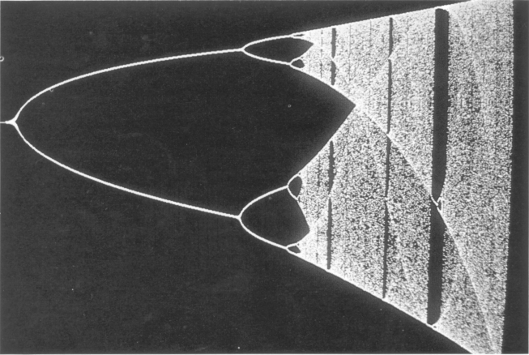
Fig. 6. Pythagoras Theorem. Fig. 7. Richard Wright, Verhulst bifurcation, digital
Arabic proof from Euclid's Elements. image, 1989. The familiar version of the diagram plotted after the `transients' have died away—the initial unruly path of the attractor before its periodicity settles down and is easier to observe.

Representation and Visualisation

The phenomenology of electronic imagery, or the way it is perceived, prompts a reassessment of its function as a transmitter of information. But other developments in the role of scientific imagery in the formation of knowledge also require a greater distinction between the terms representation and visualisation.

The object of visualisation lies implicit or latent in digital memory, waiting to be algorithmically unfurled. The image is constructed by formal rules from this symbolic structure, and its specific realisation depends on the researcher's particular line of interest and the properties of the database under investigation [13]. Because no unique representational scheme is employed, these images are commonly referred to as visualisations—our ability to create that which is visible.

Computer images exist informally in an intuitive space with other visual objects, but they derive from a formal space in the computer's memory. But substituting the term visualise for represent we create a context in which the image can exist as an independent visual object in its own space and at the same time retain a formal relation with the virtual logical space inside the computer.

A representation re-presents an object in another form or substance such that its essential features remain or directly translate into that new form. Visualisation is a specifically selective representation of data in order to produce the desired knowledge. It models certain variables and ignores others, uses certain types of geometry or scalings or filters to make some aspects more apparent and perceptible. Although all modelling involves. a simplification of reality, what we have here is a series of functional analogies rather than an abstraction of essential features; knowledge is contingent on visualisation techniques and retinal apprehension. A rendering algorithm has the power to externalise in quite arbitrary forms, from plotting quantities as colour fields to interpolating three-dimensional surfaces ready to be illuminated and viewed. Realistic image synthesis should not be the default option for visualisation; it is sometimes disadvantageous for scientific graphics. The properties that we visualise often have nothing to do with the properties of three-dimensional surfaces; this would create a conflict between the aims of visual realism and epistemological realism. Smoothly shaded geometries casting multiple shadows and reflections can easily confound the observer's understanding and at the same time increase the psychological effects of deterministic alienation by its intimidating photorealism (Fig. 8).

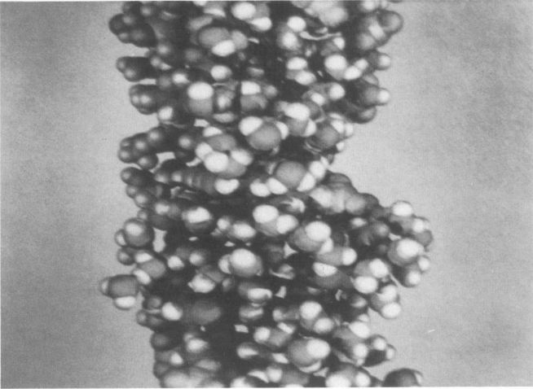
Fig. 8. William L. Luken, z-DNA (animation), digital image, 1987. Ray-tracing was used for this animation to render shadows cast by multiple light sources and inter-reflections between molecules. Unfortunately this also greatly increased the difficulty in trying to make out which is which. Source: IBM Corporation, Kingston, NY.

Most urgently researched are methods powerful enough to 'steer' the computation of an object, change the parameters of mathematical functions, select channels of data and alter the rules governing the generation of imager-. A simulation can be adjusted to produce the most satisfactory results, and its effects can be evaluated immediately. Work can begin in the exploration of this function space. In all cases this representation has no truth value; models and rendering techniques as chosen to give the most useful results as efficiently as possible, and many formal mathematical techniques can be applied without strict regard for their appropriateness to a particular real-world situation. It is precisely this flexibility that makes visualisation analytically valuable in the struggle to come to terms with the complex phenomena that science is now tackling. This is the epistemological promise of visualisation. Freed of its representational ties, it usurps the authority of measurement and quantity with the humility of resemblance and visual fluidity.

It is more accurate to think of the abstract data that form the basis of the visualisation scenario as a raw unformed state rather than as the complete embodiment of the images that arise from them. Perhaps data could be completely random and still render a meaningful form, as in synthetic texture generation. These functions generate a new sensory object, an image existent only in this tangible state. The computer still provides a means of contact between different visualisations drawn from the same source, but these data offer no more than a mediatory fabric from which to extrapolate its diverse materialisations. In fact the data-base can be said to remain undefined as an accessible object until a process to externalise it has been applied. Then it is realised, made real before our eyes. Visualisation provides accessibility to abstruse logical structures and a means of forming an intuitive conception of the subject.

Computational scientists do not use one single format for viewing their results. They habitually apply a range of techniques to attack the problem from a variety of directions. In the sprawling field of molecular graphics, each visualisation of chemical compounds concentrates on a particular property [14]. Molecules are represented using a whole vocabulary of spheres, rods, spirals, iso-surfaces and colour fields that describes their shape, structural features, electrical potential and molecular dynamics.

Just as a child learns of the qualities of a string of beads by picking them up, turning them over and examining them from different angles, so the best way to form an understanding of a multi-dimensional structure is to explore as many of its aspects as possible. We do not understand a cube if we only view it head on [15]. This approach assumes that each presentation of the object has equal value, even though it may ignore some factors, and that no universal view can encompass all the others [16]. Some images visualise other images. The Mandelbrot set provides a guide to the parameters of the Julia sets, telling us what boundaries to expect, like a visual taxonomy of mappings [17]. The results of simulation imagery are often further processed and visualised, such as by taking animations of vibrating molecules and plotting various paths separately to show how the energy is distributed between chemical bonds [18]. As each visualisation is perceptually different, so no particular visualisation of the 'object', data, function, and so forth is intrinsically more valid, closer to the 'true nature' of the object than any other. We can never really say what the object is; we see only apparitions of it. If the only way we can gain understanding of our experiment is through visualisation techniques, then the visualisations define that object, and the object 'in itself' disappears for good.
A visualisation program is many faceted. Referring to each facet as a manifestation of the same object does not unify them but causes the object to evaporate. Raw numerical data are meaningless to human sensibilities and therefore can no longer count as an observable entity. This awareness that the fundamental object we visualise can become obscured by repeated renditions and resurrected as intuitive imagery is reflected in its unreachable or inexplicable structure or dynamics. We often gain knowledge of natural phenomena by constructing analogous algorithms to model these situations by working in parallel with their observed functioning. Visualisation is one further level above this process, providing access to abstract systems through visual metaphors.

We will now briefly broaden the discussion to include this epistemological context in which computer graphics makes its contribution.

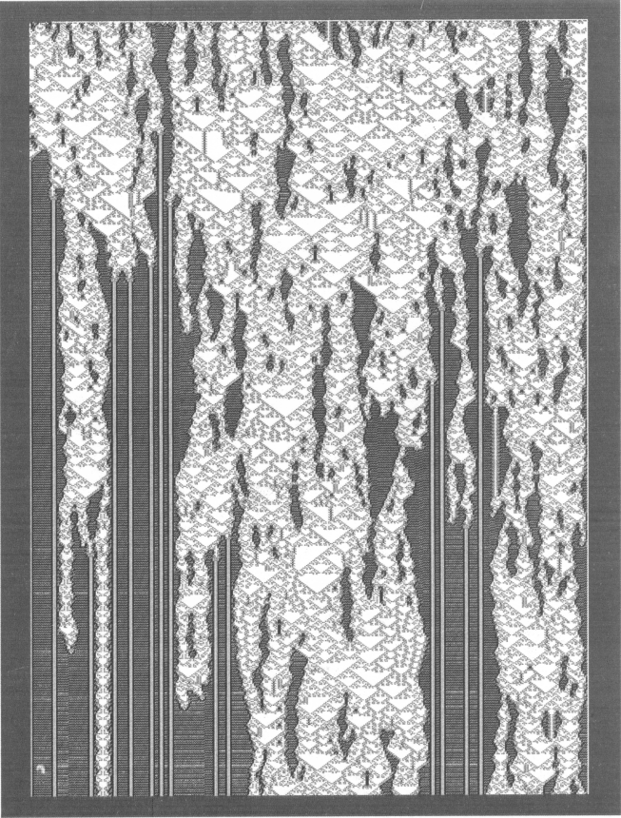
Fig. 9. Aurelio Campa, cellular automaton, digital image, 1989.
Reprinted by kind permission on the artist. All rights reserved.

ALLEGORICAL KNOWLEDGE

Model or Simulation

Cellular automata are mathematical objects that serve as models for a wide variety of natural processes (Fig. 9). Monitoring helps pick out characteristics of their intricate structure for further investigation by more rigorous means [19]. But some of their most significant properties derive from the fact that the fixed deterministic rules that control them do not preclude behaviour or states that are unpredictable, given their initial starting conditions. We cannot verify these rules except by explicitly generating them, by a 'try it and see' approach. Once these automata have begun to grow there is no way of telling whether or when they will stop, attain a regular pattern of growth or just carry on indefinitely in chaotic fashion.
These automata are called 'computationally irreducible'. This means that an automaton is one of a class of processes that are equivalent in formal terms to the operation of a digital computer—they exhibit behaviour capable of processing information in a 'universal' way. The initial conditions of the automaton are similar to the data we give to a program, and the evolution and finishing conditions (if it ever comes to a halt) are like the solution or result. Because of this, any way of predicting the result from the starting conditions alone would be equivalent to creating a new faster computer. Because we believe that the current functional definition of a general-purpose computer is composed of the barest minimum of possible operations, no such short-cuts can exist. It is thought that many natural systems also exhibit this property of being universal information processors. This situation means that many systems cannot be reduced to the abstract laws and formulas we are familiar with, and that we can investigate their properties only by directly simulating them.

Many phenomena such as biological, physical and social structures are so complex that scientists have effectively given up trying to abstract general 'models' from them. They often resort to simulation techniques to get results. Scientists have always attempted to understand the world, but the form of this understanding differs front age to age. To understand a phenomenon in terms of its simulation is generally not to understand its underlying principles. A certain phenomenon may have different 'explanations', just as the workings of the mind can be simulated in different ways. In this case knowledge of something is analogous or allegorical knowledge—not final, unique or certain, but conventional.

In the disciplines of the so-called inexact sciences—psychological, social, economic—the systems under investigation are so complex and so contingent on external factors that simulations developed to cope with these problems frequently have little theoretical justification. The mathematical description of cost analysis, for example, bears little relationship to a theoretical model of the dynamics of the situation and appears to be merely a string of arbitrary coefficients. The final form of these equations are determined from a vast amount of statistical information of past costing performances; the computer adjusts the coefficients until they fit the data. This computational technique is known as calibration [20]. The model must be re-calibrated to fit each particular application. In this kind of activity no theoretical understanding is either pertinent nor forthcoming. Not even a basic mathematical description is seen as useful, but under commercial pressures scientists have found this approach to be the most successful.
The use of computers to solve chess problems by exhaustively searching a large number of combinations of moves many turns ahead is commonly regarded as a clumsy, brute-force and merely transitional technique. But it is enthusiastically applied in crypto-analysis and molecular research [21]. In the latter discipline, the design of a new drug involves theoretical guidance from molecular chemistry in order to cut down the number of alternatives to be tested, but the onus is still on the power of the computer to perform countless checks in a trial-and-error search for the most effective solution.

In this kind of research, as opposed to reductionist analysis, the images and interactive spaces of simulations are understood more and more on the same level at which the simulated phenomenon is experienced. The gap between our conceptualisation of the sensory world and our sensory experience itself disappears, resulting in less tendency to subordinate one to the other. This epistemological background informs our use of computer graphics in the sciences.

Can Computer Graphics Be Science?

The many different solutions to simulation problems are reflected in the diversity and flexibility of visualisation tools to realise the results [22]. To maintain this adaptability and efficiency, the justification and assessment of new research in computer graphics now invariably exemplifies the pragmatic rather than the methodical approach. This computationally intensive but commercially profitable discipline demands always faster, more flexible, more efficient algorithms. A multiplicity of solutions is offered. Jean-Francois Lyotard refers to this characteristic of `postmodern' science as the pursuit of performativity [23], the pressure in a free-market economy to maximise the input/output ratio of production and to promote a new breed of techno-science. In this new commercial context, research is purposefully directed towards solving practical problems and providing profitably useful results rather than pursuing the nineteenth century ideals of truth, justice or human emancipation. Science need not gain pure knowledge at all, in the sense of a conceptual understanding, if this has no useful bearing on the task at hand: science has only to perform. A copy of any conference proceedings shows that computer graphics is a science of this type.

The ViSC report devotes a significant amount of time to equating the health of computer graphics research with the scientific base of industrial enterprise: "Support for visualisation is the most effective way to leverage this investment in national competitiveness" [24]. It regards computer imagery as an essential feature in exploiting the commercial benefits of advanced computing in technological development and practices.

Applications of computer graphics motivated by performativity can have particular influence on its role in scientific research and knowledge production. There is a danger that once programming solutions to visualisation problems have been satisfactorily implemented, they may become entrenched in methodological frameworks difficult to escape from, static interpretations restricting the innovations necessary for the unbounded growth of knowledge [25]. There may be a new temptation to identify the image with a referent, justified perhaps by a perceived ability of the computer to search a space of solutions for exactly the 'right' one. The desire for the standardisation of visualisation techniques could degenerate into a step in this direction, taken to gain a misplaced scientific respectability. If powerful interactive techniques are developed, this danger is lessened by making each package more sensitive to the needs of each project and each researcher. Likewise, the commercial demands of performativity might break up any tendency to stick with adequate models without a continual search for new and potentially more profitable alternatives.
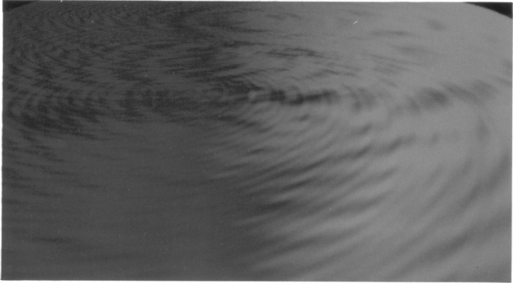
Fig. 10. Hugh Mallinder, vortex, digital image, 1987. Reprinted by kind permission of the artist. All rights reserved.

Computer graphics has been criticized for portraying itself as a science—it is not clear how it increases our knowledge or improves our understanding of the world. It continues to epitomise performativity by spending scientific research on increasing efficiency with less memory, smaller and cheaper machines, and faster execution times. Its concerns are to optimise the effectiveness of other sciences, to communicate information more clearly by taking full advantage of the perceptual discrimination of the human visual system. It is a science of analogy rather than representation, of solution rather than explanation. With the help of the computer, scientists have been able to build working symbolic models of natural phenomena. But the relationship between theory and experience has become more problematic. The desire of realism to objectify and explain experience leads to the feeling that a theoretical model has captured some 'essence' of the thing so described and is in that way even superior to it, just as for the Platonists the appearance of things was but a poor reflection of the ideal world of absolute form from which they drew their substance [26]. A computer simulation produces a different kind of understanding. Its graphical output generates an object that is on the same level of experience as the natural world of the subject. This output gives it a literalness as an object in its own right. Computer graphics can seem very realistic (or correct), but it is an alternative reality rather than a duplicate one (Fig. 10) [27]. It is more like a picture of our striving to grasp the world than an explicit modelling of it. It presents a reality terms of a visual flux, defined by a plurality of means.

Many novel scientific ideas in this century have filtered down into the public's imagination in the form of sensational claims to Eastern cosmology, Buddhist metaphysics and exotic philosophies. Postmodern science seems to have become more evocative and meaningful, not because its outlook is closer to some mystic ideology, but because it has become more formal and is therefore open to more diverse interpretations [28]. Its conventionalist character is exposed, and it is able to allow its propositions to flow freely between varied and conflicting spheres of interest. Science has become less meaningful, less tightly bound to an unchanging external world in the meta-physical sense. In order to understand a complicated phenomenon we need to apply a different model to each of its aspects and to give credence to none above the rest. The question is whether the reaction to this new contingent nature of science will be a nihilistic resignation to ultimate meaninglessness or a pluralistic embracement of the endless flux of creative thought.

Graphics makes scientific research more accessible, giving it a fluid and non totalitarian expression. This pluralistic approach should supplant performativity by giving new informal and intuitive meaning to science, at the visual level of perception and the imagistic level of conception.

SOME CONCLUSIONS AND SOME EMERGING ISSUES

What some scientists would like to have, it seems, is a new 'language of observation', a tidy standardised system of smoothly translating data into pictures and a handbook for their infallible yet somehow also creative interpretation. But unfortunately, as I have tried to show, visual objects exist in their own space and have dynamics we must respect. An article entitled something like "How to Make Sure You Get the Correct Results from Your Pictures" has not, to this author's knowledge, been written, and there are several reasons why it is unlikely, except in very specific areas.

Apart from the inherent ambiguity of perception, an attempt to develop a standardised lexicon to read scientific imagery world seem to be neither practical nor desirable. The sheer diversity of visualisation strategies within even a single discipline would be enough to render interpretive categorisation intractable, apart from the fact that we do not understand many aspects of perception. Computationally derived knowledge tends to be allegorical. Each phenomenon is simulated in its own terms, or behaviorally, and with respect to the final function we wish it to per-form. (There are some fairly basic pre-cautions that we can take when outing visualisations, such as the problem Greenberg mentions of making sure that tonal graduations are perceived as equidistant to match the numerical differentials of the data [29].) To try to fix the interpretation of imagery on higher levels would defeat the whole object of visualisation. If visualisation could be formalised, it could be computerised; we could then automate the whole process from data to algorithm to theory generation and go home. We have no reason to suppose that this is feasible: the impact of robot vision in this area is still an open question. If knowledge production were mechanised, visualisation would lose much of its meaning. The debate would move onto levels not addressable here.

Many of the problems of using imagery in science stem from what some conceive to be incompatibility between visual perception and scientific method. Some also see an incompatibility between orthodox scientific method and what scientists actually do anyway. Scientists desire the certainty of formal deduction and also the impetus of inspired insight. For these people who want to eat their cake and have it, the resort to blatantly intuitive techniques of research may prove intolerable. Much play could be made of recent advancements in the philosophy of science that assert that the ideal of methodological rigour is an abstraction never to be found in the real world beyond the arid confines of the university textbook [30]. Some current thinking even contends that a formal rational approach to science restricts the free growth of knowledge by making it difficult to justify new conceptualisations [31]. Unfortunately, once again this paper is unable to give full justice to these developments except to note that their analogy can be found in the ascension of the doctrine of performativity over the pursuit of truth in scientific praxis described in the last section.

Simplified then, the methodology of scientific visualisation is not strictly in agreement with the doctrine of rationality but is only slightly less so than empirical science in practice. Nonetheless, it has shown itself capable of extending the bounds of knowledge by the explicit use of retinal means. This is something computational scientists should not have to apologise for. Analysts need not feel guilty about having to interrogate output using the more informal methods that are appropriate to the nature of imagery. As the burden of knowledge moves from abstract theory to the simulations and patterns of behaviour visually apprehended, we will find ourselves drawn more irresistibly to the flickering images on our VDUs. People want to look at pictures. We cannot escape the fact that in this age we engage reality on visual and not literary terms. People demand the often-neglected value of meaning in science that computer imagery allows them to appropriate. The special sensory nature of electronic images will continue to cause problems in relating the conceptual to the logical to the visual, but the result should be the realisation of science as an activity that engages all of our vast mental and perceptual faculties and that ungrudgingly respects each contribution they can make.

References

1. B. H. McCormick et al., eds. "Visualization in Scientific Computing". Computing 21, No. 6 (November 1979).
2. R. S. Wolff, "Visualization in the Eve of the Scientist", Computers in Physics (May "June 1988) pp. 16-26.
3. T. Kuhn, The Structure of Scientific Revolutions (Chicago: University of Chicago Press, 1962).
4. R. I. Gregory, Eye and Brain (London: Weidenfeld and Nicholson, 1979).
5. C. Blakemore and G. G. Copper, "Development of the Brain Depends on the Visual Environment", Nature 228 (1970) Pp. 477-478.
6. E. De Bono, New Think (New York: Basic Books, 1968).
7. H. O. Peitgen and R. P. Richter, "Frontiers of Chaos". The Beauty of Fractals (New York: Springer-Verlag. 1986).
8. Software Technology Group, IBM (UK) Scientific Centre, Winchester.
9. J. Darius, "A Concise History of Scientific Photography", Beyond Vision (Oxford: Oxford University Press, 1984).
10. R. Barthes, On Photography, 1980, in The Grain of the Voice (London: Cape, 1985).
11. J. E. Hochberg, "Effects of the Gestalt Revolution: The Cornell Symposium on Perception", 1957, in D. C. Beardslee and M. Wertheimer, Readings in Perception (New York and London, 1958).
12. F. Atteneave, "Multistability in Perception", 1971, in R. Held, ed. linage. Object and Illusion. Readings from .Scientific American (San Francisco: W. H. Freeman and Company, 1974).
13. K. A. Frenkel, "The Art and Science of Visualizing Data", Comm. of the ACM 31, No. 2, 111-121 (1988).
14. Journal of Molecular Graphics (London: Butterworth). Almost any issue will suffice.
15. P. J. Davis and R. Hersh. The Mathematical Experience (London: Pelican Books, 1983).
16. A. Fournier, "Prolegomenon", in A. Fournier, ed., 'The Modelling of Natural Phenomena, Siggraph ‘87 Course Notes No. 16 Anaheim, CA, July, 1987. pp. 4-37.
17. R. I. Devaney, Introduction to Chaotic Dynamical Systems (Menlo Park: Benjamin-Cummings, 1986).
18. See [14].
19. S. Wolfram, "Computer Software in Science and Mathematics" Scientific American 251, No. 3, 85-93 (September 1984).
20. K. L. Tse and R. V. Whiny, “The Mathematics of Calibration", 1989. To be published in. Johnson, ed. The Mathematical Revolution Inspired by Computing, Conference Proceedings of the Institute of Mathematics and Its Applications (IMA), Brighton, April 1989.
21. F. Piper, "Cryptography, the Catalyst", to be published in Johnson, ed. [20].
22. C. Upson, chair, "The Physical Simulation and Visual Representation of Natural Phenomena", Technical Panel Session, Proceedings of SIGGRAPII '87, pp. 335-336.
23. J.-F. Lyotard, The Postmodern Condition- A Report on knowledge (Manchester: Manchester University Press, 1984).
24. See [1].
25. I. Lakatos and A. Musgrave, eds., Criticism and the Growth of Knowledge (Cambridge: Cambridge University Press, 1970).
26. G. Galilei, "The Assayer", 1623, in S. Drake, Discoveries and Opinions of Galileo (New York: Doubleday, 1957), pp. 111-121.
27. L. Yaeger and C. Upson, "Combining Physical and Visual Simulation—Creation of the Planet Jupiter for the Film 2010", Proceedings of SIGGRAPH '86. Computer Graphics 20, No. 4, pp. 85-93.
28. J. Powers, Philosophy and the New Physics (London: Methuen and Co., Ltd., 1982).
29. A. Wolfe, "The Visualization Round Table" Computers in Physics (May/Jane 1988) pp. 16-26.
30. See [25].
31. P. Feyerabend, Against Method (London: New Left Books, 1975)

