CATEGORY:
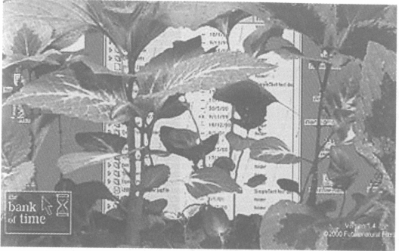

enabling it to become more flexible, adaptable, faster, efficient and pervasive. Culture, too, has become integrated in the process of the creation of capital, with cultural regeneration as the clearest example of capital's project of renewal - through ideology, reflecting these processes as natural as the growth of plants. The art world reflects these trends. Is idleness a suitable response to this tendency? This further alludes to a more militant refusal to work. Whereas Marx sought to valorise work, Negri charts a shift from exploitation to domination - politicising 'work' but differently. One suggested antagonistic technique is simply to refuse to work; paralleled by the 'artstrike' calling on cultural workers to stop making or discussing their work from 1990 to 1993 (proclaimed under the aegis of'Neoism'). The working principle here is that capitalism as an irrational system cannot be replaced by anything through better planning or anything that employs its same logic. If in general, surplus labour is stolen from the worker and turned into surplus value or capital, then a refusal to work is one considered critical response. The pointlessness of all the labouring and effort is made evident.
The Bank of Time doesn't exactly call for a refusal to work but does promote idleness as a suitable creative act. In the Bank of Time, the more idle the user the faster the plant grows and the higher up the performance table they rise. Although clearly not refusing to make art as such, Wright says: 'soon everyone will be working hard to waste as much time as possible'. Whether this is already the case in much arts practice under current conditions remains in contention.
DATA TRANSFORMATION
THE BANK OF TIME / FUTURENATURAL
http://runme.org/project/+BoT/
FEATURED BY GEOFF COX
T H E Bank of Time is a screensaver that is informed by the vagaries of the stock market, and the financial sector in general. Unlike much work in this area that uses financial markets or makes ironic reference to the business sector, The Bank of Time is a subtle and allegorical comment on idleness and growth. Wright notes how the germinating plant is a recurring metaphor in financial and investment advertising, as well as in Baroque imagery depicting the 'transience of earthly things'. It alludes to allegorical imagery in the best tradition of Benjamin in drawing together historical fragments through montage techniques to shock people into a new recognitions and understandings of the material world. In allegory, anything may mean anything else. Wright's background in computer animation is of relevance here, with animation as the task bringing inanimate matter to life - in this case the sequence is constructed by down-loading images of a growing plant frame by frame from the internet in a slowed-down parallel operation. No longer twenty-five frames per second but the user's idle time is directly proportional to the rate of growth of the plant on their desktop—from seedling to fully grown plant through to its decay reflecting the allegorical reference it evokes. On the web, the user has access to the Idleness Growth Tables to see how their performance, or the lack of it, compares to other users. Wright sees this paradoxically as idle time turned into an investment, or growth through idleness, and claims there is an economy of lost time.
The underlying politics and poetics of this, reflects the slumps and peaks of the economy in general. One might think of the culture economy too, and the Arts Council of England's (seed) funding that supported the work as part of this matrix. Wright comments on the inability of the art world to take stock of the information society and how idle most curators are in promoting and selecting this kind of work. Networked technologies have enhanced the effectiveness of global capitalism,

